Girl Site Setup-Girl 13 or Older

Previous steps: Site Registration Girl 13 and over


Once in the digital cookie site, the setup functions just like the Girl Under 13 Site Setup. The difference is that “Step 3>See Your Cookie Site and Publish” will have a button at the bottom of the page instructing the girl to: “See your site and submit for approval”

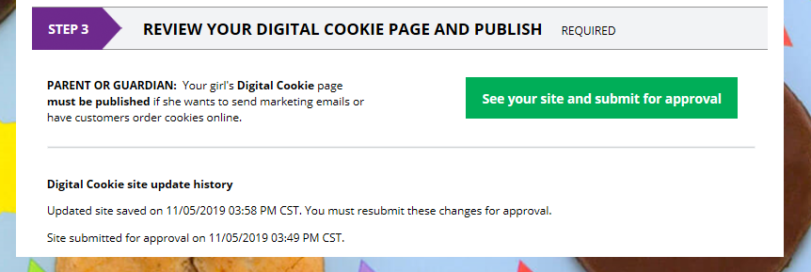


A preview of her site will display and she can either make additional edits or submit it for parent approval.

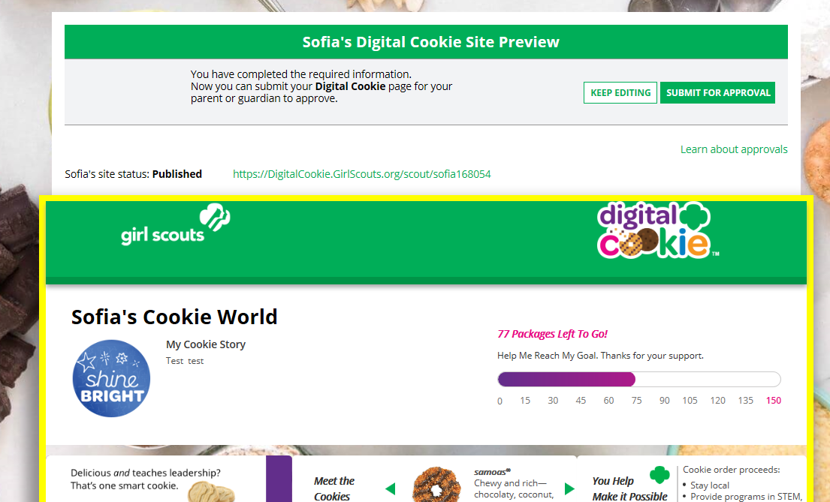

Once she has submitted the site for approval, you will receive an email that your daughter’s site needs approving.

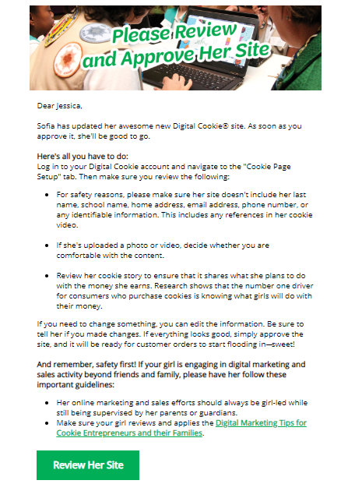


When you click the green button in the email, you will login and be sent to your Girl Scout’s site preview.
From there you can review it and either “Approve and Publish” to have her site go live, or click the “Edit’ button to make changes.
If you make changes, when they are complete, click “Approve and Publish”. Make sure to let your Girl Scout know you made changes.

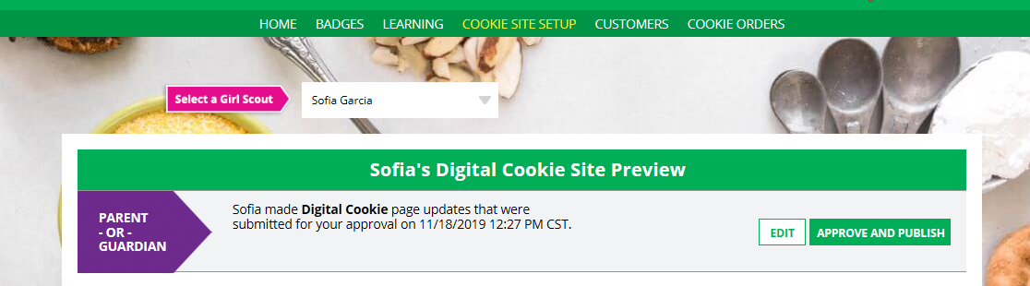


The girl will receive an email confirmation that her parent has approved her site. Now she is ready to send marketing email to customers one the council’s digital cookie sale is open.


Next Steps: Marketing to Customers

